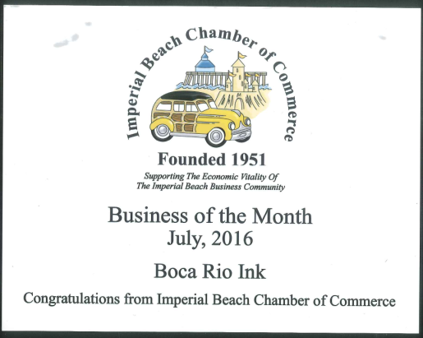
Thank you to all who attended our Networking Breakfast meeting that was held on Thursday, July 28th (fourth Thursday of the month). It was well attended with over 55 people getting up early to hear San Diego Port Commissioner Dan Malcolm give a presentation on what the Port of San Diego is doing. Very impressive from a slide on the Sun and Sea Festival, to the remaining Street End Improvements, Pond 20 Mitigation Bank, Seaport Village future, Tenth Avenue Marine Terminal Redevelopment, Harbor Island Redevelopment and many more. The slide presentation is attached for you to look at.
We announced our first Business of the Month winner for July, 2016. That honor goes to Boca Rio Ink located at 497 11th Street, Suite 10, Imperial Beach, CA. Over the next year we will choose one Business of the Month and in July, 2017 we will choose a Business of the Year (from the twelve previous Businesses of the Month) to be revealed at our General Membership meeting.
We would like to recognize businesses that donated items for our raffle drawing. Valerie Acevez from SD Manufactured Housing donated 2 tickets to Quartermania which is a fundraiser for the IB Woman’s Club, Evening Section; Spine and Sport donated a gift certificate and we had our normal one month of free advertising on the Chamber website.
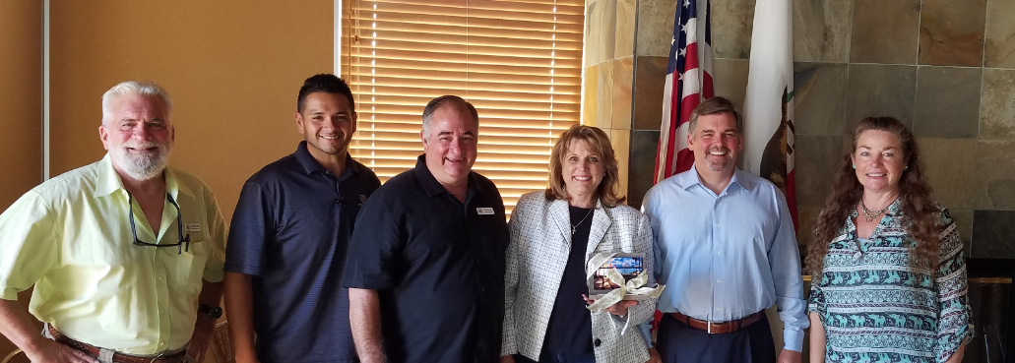
I have attached copies of the flyers that were left on the table. There is always interesting information included – please take time to look at what our businesses are doing.
Directors Jack Van Zandt, Aaron Ruiz, Mike Simms, Karen Odermatt (Speaker Dan Malcom) and Kim Paris
Thank you.
Karen Odermatt, President
Imperial Beach Chamber of Commerce

