Thursday, September 22, 2016

Thank you to all who attended the Imperial Beach Chamber of Commerce Networking breakfast on Thursday, September 22nd (fourth Thursday of each month). We had many regular attendees and guests to hear our Mayor - Serge Dedina - give an overview of the city. His enthusiasm relaying stories of growing up in Imperial Beach and then having the privilege of serving this great city was very exciting to hear. He gave a slide presentation as he spoke.

Many thanks for our raffle prize donations. Thanks to Valerie Acevez from SD Manufactured Housing who donated 4 raffle tickets to the Kiwanis Sock Hop happening October 8th (Valerie is the President of Kiwanis) and a gift card to Starbucks. I encourage everyone to “give a sample” of their business – it is a great form of advertising. I personally donated a mobile notary gift certificate and Tim Earp from Pier South Resort (which was our breakfast sponsor) donated a stay at the hotel. The Chamber also raffles off one month of advertising on our website. This is a great way to advertise your business.

Our Business of the Month Spotlight for August, 2016 will shine on K-Pasta located at 775 13th Street, Imperial Beach, CA 91932. This recognition is not an opinion on the success of the business, or an award, but more so on the perception of being a good corporate citizen. Criteria for “Business of the Month Spotlight” is:

1. Current member of the Chamber of Commerce member
2. Active in the community
3. Supportive of Community events as well as Chamber functions
4. Provides superior customer service and/or products
5. Maintains a creative, innovative and “can do” approach to business

This recognition will include a plaque, photo opportunity and a story about the business covered by one of our local newspapers.

I have attached copies of the flyers that were left on the table by your local businesses and non-profits. Lots of fun things happening in your city – please take a moment to look at all the events taking place.
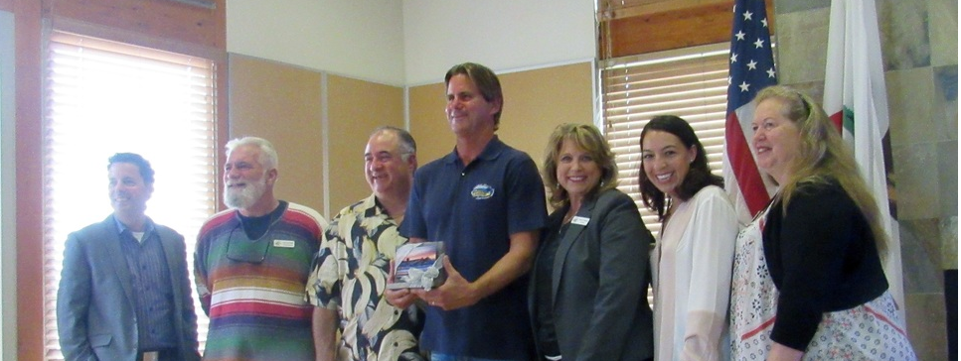
Director Tim Earp, Director Jack VanZandt, Director Mike Simms, Mayor Serge Dedina, Director Karen Odermatt, Director Vanessa Mapula-Garcia and Director Valerie Acevez.

Thank you
Karen Odermatt, President
Imperial Beach Chamber of Commerce

